



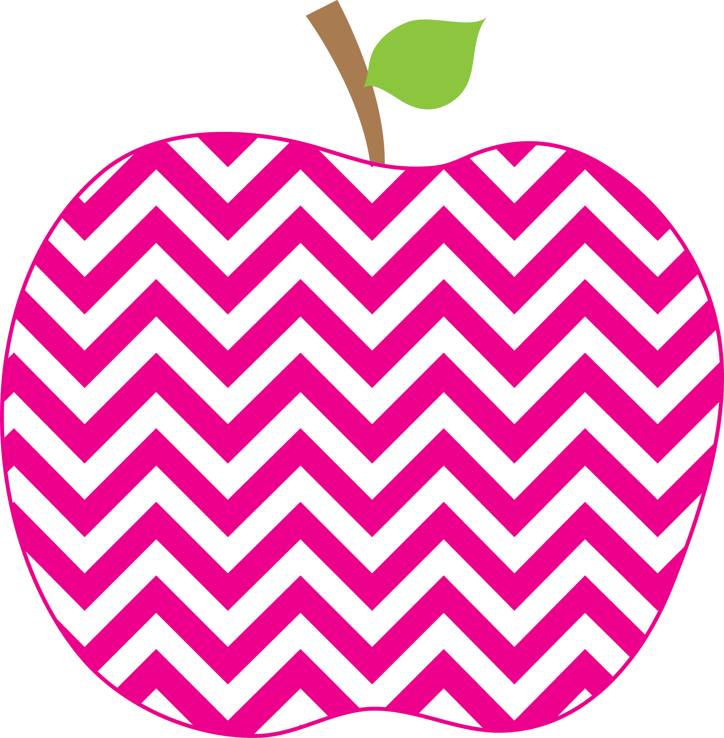

Weekly News

MRS. HOLLOWAY’S CLASS Sept 19th SSept.12t19Sep16th

Literacy- Guided Reading groups have begun based on current reading levels.

We are currently reviewing the Kindergarten sight work list. Last week the words were an, all, a, all, and. Words for this week are: for, you, he, on, as.

Reviewing the name of, sound of and formation of b and o.

The word family we will review is “all” family.

The Reading Strategy for the week is CHUNKY MONKEY.

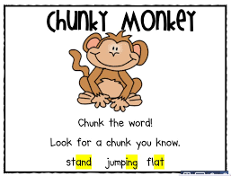
Writing- We will continue to talk about the Write Trait,”Ideas” and work on, “I can tell more about the most important details.”

Math- This week I will be doing an assessment on our Pattern unit which will be sent home for you to see and sign and return. Our Numbers to 20 unit will begin mid week.

YYWorld – Understanding that friends are important to ones happiness. We will be looking for signs of Fall.
Learning Focus for the Week
The weather is getting much cooler in the mornings, and it might be a good idea to send mini gloves with your child and a jacket.

I am still collecting Student Fees of $45. If you are unable to pay at this time please contact the office.

Home and School is tonight at 5:30 and PSSC at 6:30 if you wish to attend.
We enjoyed a performance from Samuel James at our Blues in the School Concert.

If you have not sent in your $45 school fees please do so. There were several information sheets sent home last week that some families still need to return.
Homework
Your child is bringing home two books for Home Reading. After reading have your child do an oral retell. Return on Thursday please. Please work on pattern activities sent home last week.
Information

